Reflections on the Rose Table Dialogue on
Sportsmanship in Sports Journalism and Sportscasting

June 14, 2022

Charlie Firestone, President
Rose Bowl Institute

The Rose Bowl Institute convened its first Rose Table Dialogue among 20 sports journalists and sportscasters in the Rose Bowl Stadium June 14, 2022. This is the reflection of the moderator. As the format was a moderated exchange of views, not everyone at the meeting agreed with every point made below.
Premises. The Dialogue began with the premises, discussed during the sessions, that American society is polarized, that sports gain attention from widely diverse audiences, and that sports figures and journalists have the opportunity to reach those audiences with positive messages of good sportsmanship, even if it is not the job of journalists to advocate. Often sports behavior on the field is reflected in general society – though, several at the Dialogue pointed out, it could work the other way around: bad sportsmanship may be reflecting a behavioral decline in society.
Role of Journalists. Participants differed on the role of sports journalists and sportscasters (many of whom are not journalists and often paid by the team or an entity beholden to a team.) Journalists’ first duty is to report the story, based on facts. But they have an opportunity to do more, which is to focus on the humanity, passion, values, and character behind a particular play, incident, or game. Columnists and analysts might be more comfortable doing so than a beat reporter, but whoever frames the story has major influence on the message being sent.
Sportsmanship. In focusing on sportsmanship within sports coverage, the group paused over the definition of sportsmanship – as there are cultural and philosophical differences as to what constitutes sportsmanship, who gets to define what is good or bad sportsmanship, and whose sportsmanship we should be addressing. For example, while the inclination is to look at sportsmanship on the field of play, the behavior of executives and coaches also deserve scrutiny. And not to be forgotten is fan behavior, which can be the most concerning.
Issues. Among the issues that arose in the Dialogue were (1) diversity of those being scrutinized, (2) diversity of those who report the stories and the editors and executives above them, (3) the impact of social media on the ability of traditional sports journalists to impart messages, (4) dilemmas of covering sports figures – from gaining access to players who are being shielded by team officials to reporting on unproven allegations against star players.
Social media, particularly, pose several problems. Traditional media such as newspapers and broadcasters are no longer the sole intermediaries between the sports story and the audience. Almost everyone has a voice today. Young people consume media differently from before, mainly looking to social media in one form or another. Players and teams have direct access to their audiences, which allows them greater control over the story than through journalists. And the business need for audience views has led to pressures at more traditional media for clickbait stories.
But pro-social clips can go viral as well as bad sportsmanship ones. One example was an Aaron Judge homerun caught by a Blue Jays fan and given immediately to a young Yankee fan wearing a Judge jersey.
Suggestions and Recommendations. So, what can be done to encourage more coverage of sportsmanship in sports stories and broadcasts? Among the items mentioned were:
- Establish data basepoints: currently there lacks a database from which we can determine whether sportsmanship stories are being run more or less frequently, or how the audience does or does not appreciate these efforts. The University of Maryland and the Washington Post are currently polling on sports issues. Perhaps sportsmanship content should be the next topic for an organization such as the Rose Bowl Institute to survey.
- Consciousness/searching for those story-telling moments: just being on the lookout for good sportsmanship stories, as part of the sports journalist’s story-telling, is a first step. Sports have impact – people of all backgrounds and persuasions watch sports, root for teams, and have respect for some on the field. However one defines sportsmanship, reporters can pursue stories that bring out the human element, the passion, the fairness, and mutual respect in a game that audiences, particularly young ones, will emulate.
- Manage up (editors) and down: editors and publishers want stories that resonate with audiences. Sometimes they do not see the value in a sportsmanship story and want to reassign. But reporters or columnists can push back when convinced of a good story, and often those stories can resound back to the network in a positive way. Similarly, reporters can encourage younger colleagues to get out and cover a story where their presence on the scene can make a difference.
- Encourage Association and team sportsmanship advocacy: it is not the job of a sports journalist to be an advocate, though they can write or broadcast stories that do have that effect. Rather, some suggested, teams and associations should be the advocates for good sportsmanship. A corollary to that proposition is that team officials, who are perceived by journalists today as intervening mostly to prevent negative stories, can flip that by encouraging journalists to write good human interest and sportsmanship stories about their players.
- Leadership sets the example: Finally, in the end, leadership needs to step up to the challenge. Unless leaders, whether coaches, team executives, or media executives, set a good example, how can we expect players and fans to do so? Ultimately, leadership means establishing good values for the organization and taking responsibility. Sportsmanship starts at the top!

Rose Table Dialogue: Sportsmanship in Journalism
Tuesday, June 14th, 2022
List of Participants

Jerry Bembry
Andscape/ESPN

Tim Brant
Former ABC Broadcaster

Kavitha Davidson
Correspondent on HBO's Real Sports with Bryant Gumbel

Darryl Dunn, CEO
GM/ CEO, Rose Bowl Stadium (RBOC)

Sean Farnham
ESPN

Michael Fletcher
ESPN

Sean Gregory
Time Magazine

David Hill
Hilly, Inc.

Mark Hyman, Director & Professor of the Practice, UMD Shirley Povich Center for Sports Journalism

Kevin Jackson
Fox Sports

Andy Kamenetzky
Locked on Lakers
Brian Kamenetzky
Locked on Podcast Network

Aditi Kinkhabwala
TBA, former NFL Network

Josh Lewin
UCLA Football/Basketball

Jaime Maggio
CBS Los Angeles

Arash Markazi
ESPN Radio Show host

Bill Plaschke
Los Angeles Times

Mark Rogondino
Fox 11 LA

Shelley Smith
ESPN

Matt Stevens
UCLA Football

Jim Trotter
NFL Network

Charlie Firestone, moderator
Rose Bowl Institute
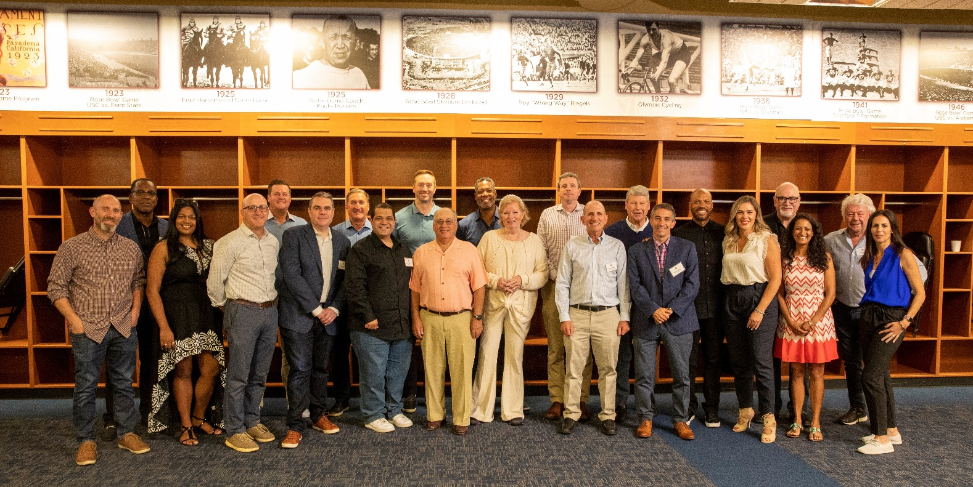
Participants in the June 14, 2022 Rose Table Dialogue on Sportsmanship in Sportscasting

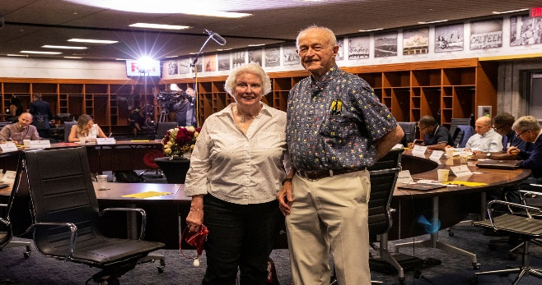
John and Bonnie DeWitt in front of the DeWitt Family Rose Table

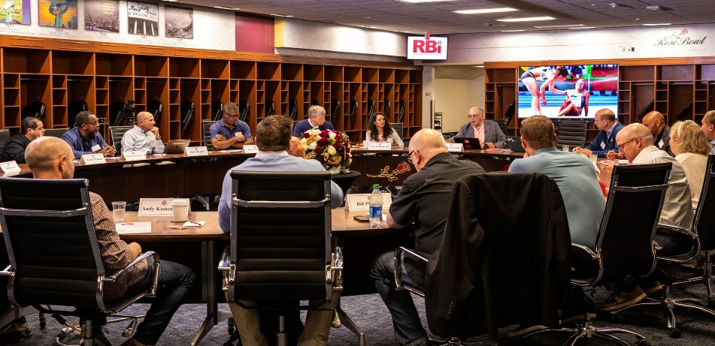
Rose Table Dialogue at the Rose Bowl,
June 14, 2022.

